

Software Requirements Specification Report

Online Dormitory Management System

Course: FER202 (Front-End web development with React)
Group: FER202_Group4
Location: Qui Nhon, October 2026

I. Project Information

1. Instructor
Full Name | Email | Phone Number | Title
 |  |  | Instructor

2. Team Members
Full Name | Email | Phone Number | Role
Nguyen Hoang Vinh | phaithayj@gmail.com | 0327191450 | Project Manager & Full-Stack Lead
Tran Cong Tien | shirotran123@gmail.com | 0374105644 | Frontend Lead & UI/UX Designer
Tran Thanh Nguyen | tranthanhnguyentgddpy20@gmail.com | 0987807074 | Backend Engineer & Database Architect
Van Thai Trung | vttrung2k6@gmail.com | 0931972866 | Frontend Developer & Integration Specialist
Dinh Thanh Trung | lqd.sik22.dinhthanhtrung@gmail.com | 0348844315 | Backend Developer & Security Analyst
Huynh Gia Kim | huynhgiakim12345@gmail.com | 0853072739 | Quality Assurance (QA) & Test Engineer

1. INTRODUCTION

1.1 Purpose
This Software Requirements Specification (SRS) document details the complete functional and non-functional requirements, system architecture, external interfaces, and operational constraints for the Dormitory Management System (DMS).
The intended audience for this document includes:
- Development Team: Frontend, Backend, and Database engineers responsible for implementing the software components.
- Course Mentors & Evaluation Board: For project scope evaluation, milestone auditing, and grading.
- Dormitory Management Board: For validating business workflows, room capacity structures, and financial billing compliance.
- Quality Assurance (QA) / Testers: For formulating end-to-end test plans and acceptance test suites.

1.2 Project Vision & Scope

1.2.1 Vision
The vision of the Dormitory Management System (DMS) is to establish a modern, transparent, and fully automated cloud-based platform that replaces traditional paper-based, manual dormitory administration. The system aims to eliminate administrative bottlenecks during seasonal peak registration, prevent utility billing disputes, eliminate manual room approval overhead, and provide residents with a seamless, mobile-friendly self-service experience.

1.2.2 Scope

The scope of the DMS product encompasses the following major operational areas:

Domain-Differentiated Authentication: Automated identity routing separating students (logging in via personal Gmail pre-registered with the university) from staff, managers, and technicians (logging in strictly via university-issued @fpt.edu.vn or @fe.edu.vn accounts).

- Hierarchical Facility Management (1:4:6 Topology): Comprehensive inventory modeling structured as Block → Floor → Room → Compartment → Bed, where 1 Room contains 4 Compartments, and 1 Compartment contains 6 individual Beds (total capacity: 24 students/room).

- Visual Bed Selection & Instant Auto-Approval: First-Come, First-Served self-service bed picking with a real-time 15-minute temporary hold lock. Eliminates manual manager approval by automatically validating prerequisites (gender matching, active student status, no disciplinary debt) and auto-activating reservations upon confirmed digital payment.

- Digital Handover & Life-Cycle Records (Check-in & Check-out): Paperless asset handover tracking featuring photographic condition evidence, digital asset checklists (keys, mattresses, individual lockers, shared room fixtures), and automated deposit reconciliations upon checkout.

- Smart Room-Level Utility Metering & Pro-Rata Split Billing: Room-level electric and water meter recording with photo verification, progressive tariff and Value-Added Tax calculation, and automated equal division across all active residents residing in the room during that billing period.

- Integrated Cashless Payments: Generation of dynamic VietQR and VNPay payloads for individual split invoices, preventing dependency on roommates collecting cash on each other's behalf.

- Operational Security & Facilities Support: Curfew tracking (logging late arrivals past 23:00 with prior leave request verification), disciplinary penalty tracking, and multi-tier maintenance ticketing.

Out-of-Scope:

- Direct IoT hardware sensor integration for automatic meter reading (meters are read and validated via staff input with photographic proof).
- Cafeteria meal plans and physical smart-card hardware fabrication.

1.3 User Classes

User Class | Description & Key Responsibilities | Access Credentials & Platform Access
Guest | Unauthenticated prospective students or parents browsing dormitory facilities, room layouts, policies, and public pricing. | No login required. Public web pages only.
Student / Resident | Enrolled students reserving beds, reviewing digital contracts, signing digital check-in/out handover forms, paying split bills, and submitting maintenance tickets. | Personal Gmail pre-registered in the university’s admission database. Responsive Mobile/Desktop Web.
Dormitory Manager / Staff | Administrative personnel overseeing building occupancy, supervising the automated booking pipeline, logging room meter indices, conducting check-in/out inspections, and enforcing dorm policies. | University-issued Email (@fpt.edu.vn / @fe.edu.vn). Staff Portal Web Application.
Technician / Security Guard | Facilities and security staff responsible for executing maintenance requests, patrolling buildings, and logging out-of-hours gate entries past 23:00. | University-issued Email (@fpt.edu.vn / @fe.edu.vn). Mobile Web / Tablet interface.

1.4 Glossary
Term / Acronym | Definition & Domain Context
DMS | Dormitory Management System – The centralized web application governing all dormitory operations.
Room | The primary residential flat unit, equipped with a master electric meter, a master water meter, and shared sanitary facilities. Contains exactly 4 Compartments.
Compartment | A distinct living cubicle within a Room. Contains exactly 6 Beds, equipped with independent lighting, fans/air conditioning, and 6 secure individual lockers.
Bed | The atomic rentable inventory unit allocated to a single student. Identified by the canonical format: [Room]-[Compartment]-[Bed] (e.g., A205-B1-G03).
Personal Gmail Login | Authentication mechanism restricted to students, validating their personal @gmail.com address against pre-loaded admission student master data.
Institutional SSO | Single Sign-On reserved exclusively for staff and administrators holding @fpt.edu.vn or @fe.edu.vn email domains.
Hold Lock | A temporary database reservation placed on a selected bed while the student completes the initial reservation deposit payment.
Auto-Approval Engine | Background service that verifies enrollment eligibility, gender constraints, and payment confirmation to instantly approve a room booking without manual manager intervention.
Digital Handover Record | An electronic inspection form signed at Check-in and Check-out recording asset states, baseline meter values, and potential damage deductions.

2. OVERALL DESCRIPTION & FUNCTIONAL REQ

2.1 Product Perspective

DMS is an independent, 3-tier cloud web application integrated with campus identity directories and commercial fintech payment gateways. It interfaces directly with university student databases to authenticate personal Gmail accounts and links with real-time banking webhooks to process payments.

2.1.1 System Architecture & Core Pipeline

Pipeline 1: Authentication & Domain-Based Routing Pipeline
- Pipeline 2: Visual Bed Reservation & Zero-Touch Auto-Approval Pipeline
- Pipeline 3: Digital Check-in & Check-out Handover Pipelines
- Pipeline 4: Room-Level Metering, VAT & Split Billing Pipeline

2.1.2 External Interfaces

1. User Interfaces (UI)

Design Philosophy: Modern, minimalist, mobile-responsive layout utilizing Tailwind CSS, ShadCN UI components, and accessible color contrasts.

Interactive Floor & Room Visualizer: Hierarchical visual selection displaying:

Building overview → Floor selection → Room card (showing capacity: e.g., 18/24 occupied).

Room detail modal showing 4 Compartment(A, B, C, D) and 6 individual beds per Compartment.

Bed nodes color-coded: Green (Available), Amber (15-min Hold), Grey (Occupied), Red (Maintenance).

Student Invoice & Handover Portal: Transparent billing view displaying room meter baseline photos, calculation breakdown (kWh, m^3, VAT percentage, count of roommates ), and a dynamic VietQR code.

Staff Mobile Inspection Console: Touch-friendly checklist interface allowing photo uploads directly via smartphone cameras during check-in/check-out.

2. Hardware Interfaces

Client Devices: Standard Web browsers running on Desktop PCs, Laptops, Tablets, and Smartphones.

Device Peripherals:

Smartphone/Tablet Cameras: Utilized by staff to capture meter readings and asset damage during check-in/check-out.

Barcode/QR Scanners: Optional USB/Bluetooth scanners used by security guards to scan Student ID cards at the dorm gate during curfew checks.

3. Software Interfaces

Google Identity Services (OAuth 2.0 API): Provides single sign-on authentication and profile retrieval for both personal Gmail accounts and institutional Google Workspace accounts.

Fintech Payment Gateways (VietQR / VNPay API):

Generates dynamic standard EMVCo-compliant QR codes encoding beneficiary account details, exact currency values, and unique bill IDs.

Webhook listener (IPN endpoint) for real-time transaction confirmation triggering the Auto-Approval engine.

Cloud Media Storage (Cloudinary API): Cloud storage handling image uploads, optimizations, and secure URL delivery for meter verification photos and room handover evidence.

Messaging & Notification Services (SMTP / Resend API): Automated dispatch of booking confirmations, PDF electronic contracts, invoice generation notifications, and curfew infraction warnings.

4. Communications Interfaces

Network Protocols: HTTPS over TLS 1.3 for all client-server communications to protect credentials and personal data.

Data Interchange Format: RESTful JSON payloads for all API requests and responses.

Real-time WebSockets / Server-Sent Events (SSE): Synchronizes real-time bed holding states across clients, preventing two students from attempting to select the same bed simultaneously.

2.2 Detailed Use Case Specifications (mỗi UC làm theo mẫu như dưới đây)
Dormitory Management System (DMS)
Full Use Case Specifications (28 Use Cases)
Module 1: Authentication & Identity Management
UC Code & Name | UC-01: View Dorm Information, Pricing, Rules & Available Beds
Actor | Guest, Student, Dorm Manager, Technician / Guard, Admin
User Story | As a Guest, I want to view dorm facilities, room prices, general rules and available beds, so that I can decide whether to apply for dormitory housing.
Preconditions | 1. The DMS public web portal is reachable.  2. Blocks, rooms, compartments, beds and price lists have been configured by Admin (UC-05, UC-06, UC-07).
Main Flow | 1. Actor opens the DMS portal home page.  2. System displays the dorm introduction, facilities, room price list and general regulations.  3. Actor browses the catalogue Block > Room > Compartment > Bed.  4. System shows real-time bed availability with color codes: green (Available), gray (Occupied), orange (Holding), red (Maintenance).  5. Actor filters the catalogue by block or block type (Male / Female / International).
Alternate Flows | 3a. No Available Beds: All beds in the selected scope are taken → System displays “No available beds” and suggests other blocks.  4a. Data Load Failure: System cannot retrieve inventory → System displays a retry message and logs the error.
Postconditions | Actor has viewed up-to-date dorm information. No data is modified.

UC Code & Name | UC-02: Login with Google (Gmail Roster Match / Staff Domain Check)
Actor | Student, Dorm Manager, Technician / Guard, Admin, Google OAuth2 Service (Secondary Actor)
User Story | As a Student or staff member, I want to log in with my Google account, so that I can securely access the features permitted for my role without a separate password.
Preconditions | 1. User owns a valid Google account: personal Gmail (Student) or @fpt.edu.vn / @fe.edu.vn (staff).  2. Student Gmail is pre-imported in the student records; staff account exists in USERS with an active role.
Main Flow | 1. User clicks “Login with Google” on the portal.  2. System redirects the browser to the Google OAuth2 consent screen.  3. User authenticates with Google and grants profile permission.  4. Google returns an authorization code / ID token to the backend callback URL.  5. Backend verifies the token and extracts the user email.  6. If the user is a Student, System matches the Gmail against the imported student records and links MSSV, full name and course. If the user is staff, System validates that the domain is @fpt.edu.vn or @fe.edu.vn.  7. System resolves the role, issues a JWT Access Token (30 minutes) and a Refresh Token stored in an HttpOnly Secure Cookie (see UC-03).  8. System redirects the user to the dashboard for their role.
Alternate Flows | 3a. Google Authentication Cancelled / Failed: User cancels or Google rejects → System returns to the login page with “Google authentication cancelled”.  6a. Student Gmail Not Linked: Gmail is not in the student records → System denies access with “Email is not linked to a student profile. Please contact the Student Affairs Office” and logs the event.  6b. Invalid Staff Domain: Staff signs in with @gmail.com, @yahoo.com or another domain → System denies access to the management portal.  6c. Account Inactive / Suspended: Account is locked → System displays an error and denies login.
Postconditions | A secure JWT session is established and RBAC is applied to all subsequent API calls.

UC Code & Name | UC-03: Manage Session & Logout (JWT / Refresh Token)
Actor | Student, Dorm Manager, Technician / Guard, Admin
User Story | As a logged-in user, I want to log out safely or revoke my sessions on other devices, so that my account stays protected on shared or lost devices.
Preconditions | 1. User is logged in via UC-02 with a valid session.
Main Flow | 1. User clicks “Logout” or “Sign out of all other devices”.  2. System invalidates the Refresh Token of the current session (or of all other sessions if requested).  3. System clears the HttpOnly Secure Cookie on the current device.  4. System redirects the user to the public home page.
Alternate Flows | 2a. Access Token Expired: Access Token (30 minutes) has expired → System uses the Refresh Token to issue a new Access Token transparently.  2b. Refresh Token Expired / Revoked: System forces re-authentication through UC-02.
Postconditions | Targeted sessions are invalidated; revoked tokens can no longer access any API.

UC Code & Name | UC-04: Manage Personal Profile
Actor | Student
User Story | As a Student, I want to view and update my personal and emergency-contact information, so that the dorm always has my correct details.
Preconditions | 1. Student is logged in via UC-02.
Main Flow | 1. Student opens “My Profile”.  2. System displays profile data: MSSV, full name, Gmail (read-only) and editable fields.  3. Student edits phone number, CCCD/CMND, portrait photo, hometown address and parent emergency contact (name, phone, relationship).  4. Student clicks “Save”.  5. System validates the input, encrypts CCCD and parent phone number, saves the changes and shows a success message.
Alternate Flows | 3a. Attempt to Edit Locked Fields: Student tries to change MSSV, full name or Gmail → System blocks the change; only Admin may adjust these (UC-08).  4a. Validation Error: Invalid phone / CCCD format or oversized photo → System highlights the fields and rejects the save.
Postconditions | Student profile is updated; sensitive data is stored encrypted.

Module 2: Dorm Inventory (Room - Compartment - Bed)
UC Code & Name | UC-05: Manage Blocks & Floors
Actor | Admin
User Story | As an Admin, I want to define blocks and their floors, so that the dorm structure and gender rules are correctly represented in the system.
Preconditions | 1. Actor is authenticated via UC-02. Actor has Admin role.
Main Flow | 1. Admin opens “Block Management”.  2. Admin creates or edits a block (e.g. Dom A) with name, block type (Male / Female / International) and number of floors.  3. Admin declares the emergency exits and security cameras of each block.  4. Admin clicks “Save”.  5. System validates and saves the block and its floors, then shows the updated list.
Alternate Flows | 2a. Duplicate Block Name: Name already exists → System rejects with an error.  2b. Delete Block With Rooms: Block still has rooms or active contracts → System blocks deletion.
Postconditions | Block and floor records exist and can be used for room configuration (UC-06).

UC Code & Name | UC-06: Manage Room - Compartment - Bed Structure
Actor | Admin
User Story | As an Admin, I want to configure rooms with 4 compartments of 6 beds each, so that every bed has a unique standardized code and status.
Preconditions | 1. Actor is authenticated via UC-02. Actor has Admin role.  2. Target block and floor exist (UC-05).
Main Flow | 1. Admin selects a block and floor and clicks “Add Room”.  2. Admin enters a unique room code (e.g. A205) and the shared equipment: 1 electricity meter, 1 water meter, water heater, mirror, sink.  3. System automatically generates 4 compartments (A-D) and 6 beds (G01-G06) per compartment, i.e. 24 beds per room.  4. System assigns standardized bed codes [Room]-[Compartment]-[Bed] (e.g. A205-B1-G03).  5. Admin reviews and clicks “Save”.  6. System persists rooms, compartments and beds with initial status “Available”.
Alternate Flows | 2a. Duplicate Room Code: Code already exists in the block → System rejects with an error.  5a. Change Status: Admin sets a room or bed to Maintenance / Locked → System updates the status, hides it from booking and warns if an active contract exists.
Postconditions | Room, compartments and beds are stored with correct hierarchy, codes and status.

UC Code & Name | UC-07: Configure Room Pricing, Utility Rates & VAT
Actor | Admin
User Story | As an Admin, I want to configure room prices, electricity/water rates and VAT, so that invoices are calculated with current official rates.
Preconditions | 1. Actor is authenticated via UC-02. Actor has Admin role.
Main Flow | 1. Admin opens “Pricing Configuration”.  2. Admin sets room prices, deposit amount, electricity rate, water rate, room cleaning/garbage fee and VAT rates (electricity, water; e.g. 8% or 10%).  3. Admin sets the effective date and the late-payment penalty rule.  4. Admin clicks “Save”.  5. System validates and stores the configuration with version history.
Alternate Flows | 2a. Invalid Value: Negative rate or VAT outside allowed range → System rejects and highlights the field.  3a. Retroactive Change: Effective date is in the past → System warns that issued invoices remain unchanged.
Postconditions | New rates are active from the effective date and used by UC-10 and UC-17.

UC Code & Name | UC-08: Manage Accounts & Role-Based Permissions (RBAC)
Actor | Admin
User Story | As an Admin, I want to manage staff and student accounts and roles, so that only authorized people can use each function.
Preconditions | 1. Actor is authenticated via UC-02. Actor has Admin role.
Main Flow | 1. Admin opens “Account Management”.  2. Admin creates a staff account (@fpt.edu.vn / @fe.edu.vn) and assigns a role (Dorm Manager, Technician / Guard, Admin).  3. Admin imports or edits student records (MSSV, full name, registered Gmail), including corrections to locked fields.  4. Admin activates, deactivates or changes the role of an account.  5. System saves the changes and records an audit log entry.
Alternate Flows | 2a. Invalid Staff Domain: Email is not @fpt.edu.vn / @fe.edu.vn → System rejects the staff account.  3a. Import Error: Student file has duplicate MSSV / Gmail or invalid format → System reports the exact rows and cancels the import.
Postconditions | Accounts and roles are updated; permission changes take effect on the next login.

Module 3: Booking, Contract, Check-in & Check-out
UC Code & Name | UC-09: Select Bed Visually (Block > Room > Compartment > Bed)
Actor | Student
User Story | As a Student, I want to pick a specific bed from a live visual map, so that I know exactly where I will live before paying.
Preconditions | 1. Actor is authenticated via UC-02.  2. Booking period is open.  3. Student has no active contract for the same period.
Main Flow | 1. Student opens “Book a Bed” and selects a block.  2. System lists rooms of the block (filtered by the Student’s gender).  3. Student selects a room, then a compartment (1-4).  4. System displays the 6 beds with real-time colors: green (Available), gray (Occupied), orange (Holding), red (Maintenance).  5. Student clicks one green bed to select it.  6. System proceeds to UC-10.
Alternate Flows | 2a. Wrong Gender Block: Student selects a block of another gender → System blocks the selection with a notice.  5a. Bed Just Taken: Bed became unavailable → System refreshes the map and asks the Student to choose another bed.
Postconditions | Student has chosen exactly one specific bed to hold.

UC Code & Name | UC-10: Hold Bed Temporarily (15 min) & Pay Deposit / Room Fee
Actor | Student, VietQR / VNPay Gateway (Secondary Actor), System Scheduler (Secondary Actor)
User Story | As a Student, I want the chosen bed reserved for 15 minutes while I pay online, so that nobody else can take it before I finish.
Preconditions | 1. Actor is authenticated via UC-02.  2. Student has selected an available bed (UC-09).
Main Flow | 1. Student clicks “Confirm Hold”.  2. System places a 15-minute Hold Lock on the bed (Redis / pessimistic lock) and shows a countdown.  3. System generates a VietQR / VNPay payment for the deposit / room fee.  4. Student completes the payment.  5. Payment gateway sends an IPN webhook to the system.  6. System hands the paid booking to the approval engine (UC-11).
Alternate Flows | 2a. Concurrent Selection: Another student locked the bed first → System denies the hold and asks for another bed.  4a. Hold Expired: No successful payment within 15 minutes → System Scheduler cancels the hold and sets the bed to “Available”.  5a. Payment Failed: Gateway reports failure → System keeps the hold until expiry and lets the Student retry.
Postconditions | The bed is held and paid, or released back to Available.

UC Code & Name | UC-11: Auto-Approve Booking (Approval Engine)
Actor | System (Approval Engine), Dorm Manager (monitoring), VietQR / VNPay Gateway (Secondary Actor)
User Story | As a Dorm Manager, I want valid bookings approved automatically, so that no staff effort is spent on manual approval during peak periods.
Preconditions | 1. A booking exists with a successful payment webhook (UC-10).
Main Flow | 1. System receives the successful IPN webhook.  2. System checks: (1) Student gender matches the block/room; (2) account is valid: active, no unpaid debt, not suspended; (3) payment is successful.  3. System sets the booking to “Auto-Approved” and the bed to “Booked / Awaiting Check-in”.  4. System triggers contract generation (UC-12).  5. Dorm Manager monitors the list and statistics of approved bookings.
Alternate Flows | 2a. Condition Not Met: Gender mismatch, unpaid debt or suspension → System rejects the booking, releases the bed and notifies the Student of the refund process.  2b. Duplicate Webhook: Same transaction received twice → System processes it once (idempotent).
Postconditions | Booking is approved with no manual action; bed status is updated.

UC Code & Name | UC-12: Generate & Send Electronic Contract (PDF)
Actor | Student, System, Email Service - Resend / Nodemailer (Secondary Actor)
User Story | As a Student, I want to receive my electronic accommodation contract by email, so that I have official proof of my booking.
Preconditions | 1. Booking is Auto-Approved (UC-11).
Main Flow | 1. System generates a unique contract number.  2. System fills the contract: full name, MSSV, bed code [Room]-[Compartment]-[Bed], term, rent and deposit paid.  3. System renders the contract as a PDF and stores it.  4. System emails the PDF and an in-app notification to the Student.
Alternate Flows | 4a. Email Delivery Failure: Email service fails → System retries automatically and keeps the contract downloadable in the Student’s account.
Postconditions | Contract exists with status “Awaiting Check-in” and has been delivered to the Student.

UC Code & Name | UC-13: Monitor Bookings & Occupancy, Support Change / Cancellation
Actor | Dorm Manager, Admin
User Story | As a Dorm Manager, I want to monitor bookings and occupancy and handle change or cancellation requests, so that exceptions are resolved quickly.
Preconditions | 1. Actor is authenticated via UC-02. Actor has Manager or Admin role.
Main Flow | 1. Actor opens “Booking Monitor”.  2. System displays bookings, occupancy by bed / compartment / room and pending change or cancellation requests.  3. Actor opens a request and reviews the booking and payment history.  4. Actor approves or rejects the change / cancellation and enters a note.  5. System updates the booking, bed status and contract, and notifies the Student.
Alternate Flows | 4a. Refund Required: Cancellation of a paid booking → System calculates the refund according to policy and records it for payment.  4b. Target Bed Unavailable: Requested new bed is not free → System asks the Actor to choose another bed.
Postconditions | Booking data is consistent and the Student is notified of the outcome.

UC Code & Name | UC-14: Perform Check-in (Room & Asset Handover)
Actor | Dorm Manager, Student
User Story | As a Dorm Manager, I want to hand over the bed and assets with a digital record signed by the Student, so that room condition is documented at move-in.
Preconditions | 1. Actor is authenticated via UC-02. Actor has Manager role.  2. Contract status is “Awaiting Check-in” (UC-12).
Main Flow | 1. Student arrives; Manager opens the contract in DMS.  2. Manager verifies the Student’s CCCD and student card photo.  3. Manager completes the electronic asset checklist: shared room equipment (main door, water heater, lights) and compartment / bed equipment (mattress, locker, sockets, fan).  4. Manager records the initial electricity and water meter readings of the room (UC-16).  5. Manager photographs any existing damage and attaches it to the record.  6. Student reviews the record and taps “Confirm Check-in” on their phone.  7. Manager hands over the key / access card; System sets the contract to “Active” and the bed to “Occupied”.
Alternate Flows | 2a. Identity Mismatch: Documents do not match → Manager stops the check-in and contacts the Student Affairs Office.  6a. Student Disputes Record: Student declines to confirm → Manager corrects the checklist or adds notes and requests confirmation again.
Postconditions | Handover record is saved with photos and meter readings; contract is Active.

UC Code & Name | UC-15: Perform Check-out (Room Return & Settlement)
Actor | Student, Dorm Manager, VietQR / VNPay Gateway (Secondary Actor)
User Story | As a Student, I want to check out and receive a clear settlement and deposit refund, so that I leave the dorm without disputes.
Preconditions | 1. Student is logged in via UC-02 with an Active contract.  2. Manager is authenticated with Manager role.
Main Flow | 1. Student submits a check-out request (or the term ends).  2. System schedules a room inspection.  3. Manager compares the room with the Check-in record for bed, locker lock and compartment / room equipment damage.  4. Manager records the final electricity and water meter readings (UC-16).  5. System calculates the settlement: unpaid utilities until departure and compensation for damage are deducted from the deposit.  6. Student reviews and confirms; System refunds the remaining deposit to the Student’s bank account.  7. Manager collects the key / card; System sets the bed to “Available” and the contract to “Ended”.
Alternate Flows | 3a. Damage Found: Damage exists → Manager photographs it, enters the compensation cost and adds it to the settlement.  5a. Deposit Insufficient: Debts exceed the deposit → System issues an invoice for the balance and holds the contract closure until paid.  6a. Refund Failure: Bank transfer fails → System flags the refund for manual handling.
Postconditions | Settlement is completed; contract is Ended and the bed is available again.

Module 4: Utility Meters & Split Billing
UC Code & Name | UC-16: Record Room Electricity & Water Meter Readings
Actor | Dorm Manager, Technician / Guard (support), Admin
User Story | As a Dorm Manager, I want to record each room’s meter readings with photo evidence, so that invoices are based on transparent, verifiable numbers.
Preconditions | 1. Actor is authenticated via UC-02. Actor has Manager, Technician or Admin role.  2. Rooms have active electricity and water meters.
Main Flow | 1. Between the 25th and 28th of the month, Actor opens “Record Meters” on mobile web (or uploads the standard Excel template).  2. Actor selects a room and enters the new electricity and water readings.  3. Actor attaches a photo of each meter.  4. System validates the readings against the previous month.  5. System saves the readings with photos and timestamps.
Alternate Flows | 4a. Reading Lower Than Previous: New < old → System rejects and asks for correction.  4b. Abnormal Spike: Consumption exceeds 200% of last month → System warns of suspected leak or short circuit and requires confirmation.  2a. Excel Error: Invalid rows in file → System lists the row numbers and rejects the import.
Postconditions | Verified readings and photos are stored for the billing cycle.

UC Code & Name | UC-17: Calculate Utility Bill (VAT) & Split Equally Among Residents
Actor | Dorm Manager, Admin
User Story | As a Dorm Manager, I want to trigger automatic bill calculation and equal splitting per room, so that every resident gets a fair, separate invoice.
Preconditions | 1. Actor is authenticated via UC-02. Actor has Manager role.  2. Room readings recorded (UC-16); rates and VAT configured (UC-07).
Main Flow | 1. Manager selects the billing period and clicks “Calculate & Split Bills”.  2. System computes consumption ΔE and ΔW and the amounts with VAT for each room, plus the cleaning / garbage fee.  3. System retrieves the N active residents of each room in the period.  4. System divides the room total by N to get each resident’s share.  5. System creates N separate invoices with meter photos, readings, VAT, N and the amount due.  6. System notifies residents (UC-19).
Alternate Flows | 3a. Mid-Term Check-in / Early Check-out: Resident stayed part of the period → System applies pro-rata by actual days stayed.  1a. Missing Readings: Room has no readings → System skips it and reports it to the Manager.  4a. Rounding Remainder: Total not divisible → System allocates the remainder so invoices sum exactly to the room total.
Postconditions | Individual invoices exist for every resident; all writes are in one ACID transaction.

UC Code & Name | UC-18: View & Pay Personal Invoice via VietQR
Actor | Student, Dorm Manager (review), VietQR / VNPay Gateway (Secondary Actor)
User Story | As a Student, I want to view and pay my own utility invoice by QR, so that I pay only my share without a room representative.
Preconditions | 1. Actor is authenticated via UC-02.  2. An invoice has been issued to the Student (UC-17).
Main Flow | 1. Student opens “My Invoices” and selects an invoice.  2. System displays room meter photo, old / new readings, room total, VAT, N and the individual amount.  3. Student clicks “Pay”.  4. System shows a dynamic VietQR with the exact amount and transfer content “DMS [InvoiceCode] [MSSV]”.  5. Student pays with a banking app; the gateway confirms the transaction.  6. System marks the invoice as Paid and sends a receipt.
Alternate Flows | 5a. Payment Not Confirmed: No confirmation → invoice stays Unpaid; Student may retry.  1a. Overdue Invoice: Due date passed → System adds a late-payment penalty to the amount due.
Postconditions | Invoice status and debt are updated; a receipt is available.

UC Code & Name | UC-19: Send Invoice Notifications & Payment Reminders
Actor | System Scheduler (Secondary Actor), Student, Email Service - Resend / Nodemailer (Secondary Actor)
User Story | As a Student, I want to be notified of new invoices and upcoming due dates, so that I avoid late fees.
Preconditions | 1. Invoices have been issued (UC-17).
Main Flow | 1. System sends an email and in-app notification when an invoice is issued.  2. System Scheduler checks due dates daily.  3. System sends reminders 3 days and 1 day before the due date to unpaid invoices.  4. After the due date, System updates the debt and applies the late-payment penalty.
Alternate Flows | 1a. Email Failure: Delivery fails → System retries and keeps the in-app notification.
Postconditions | Notifications are logged; overdue debts and penalties are up to date.

Module 5: Maintenance Tickets
UC Code & Name | UC-20: Submit Repair Ticket
Actor | Student
User Story | As a Student, I want to report broken equipment with photos and urgency, so that it is fixed quickly.
Preconditions | 1. Actor is authenticated via UC-02.  2. Student has an Active contract.
Main Flow | 1. Student opens “Report Issue”.  2. Student selects the location: shared room area (shower, water heater, balcony light, main door lock) or personal compartment (fan, air conditioner, bed socket).  3. Student describes the issue, uploads photos and sets urgency: Normal or Urgent (electric leak / flooding risk).  4. Student submits the ticket.  5. System creates the ticket with status “New” and notifies the Manager.
Alternate Flows | 3a. Urgent Ticket: Urgent selected → System flags it as high priority and alerts the Manager immediately.  3b. Invalid Upload: Unsupported or oversized photo → System rejects the file.
Postconditions | A repair ticket exists with location, photos and urgency.

UC Code & Name | UC-21: Receive & Dispatch Repair Tickets
Actor | Dorm Manager, Admin
User Story | As a Dorm Manager, I want to review and assign repair tickets to technicians, so that issues are handled by the right person.
Preconditions | 1. Actor is authenticated via UC-02. Actor has Manager or Admin role.  2. Ticket exists (UC-20).
Main Flow | 1. Actor opens the ticket list sorted by urgency.  2. Actor reviews details and photos.  3. Actor assigns the ticket to a Technician.  4. System sets the status to “Assigned” and notifies the Technician and Student.
Alternate Flows | 3a. Invalid / Duplicate Ticket: Actor rejects with a reason → System closes it and notifies the Student.
Postconditions | Ticket is assigned and traceable.

UC Code & Name | UC-22: Receive & Repair
Actor | Technician / Guard
User Story | As a Technician, I want to record the repair result and materials used, so that work is documented.
Preconditions | 1. Actor is authenticated via UC-02. Actor has Technician role.  2. Ticket is assigned (UC-21).
Main Flow | 1. Technician opens assigned tickets.  2. Technician performs the repair and sets the status to “In Progress”.  3. Technician uploads result photos and records replaced materials.  4. Technician marks the ticket “Completed”.  5. System notifies the Student to confirm.
Alternate Flows | 2a. Cannot Repair Immediately: Parts unavailable → Technician sets “Waiting for Parts” with a note and the Manager is notified.
Postconditions | Ticket is Completed and awaits Student acceptance.

UC Code & Name | UC-23: Accept Repair & Rate Satisfaction
Actor | Student
User Story | As a Student, I want to confirm the repair and rate it, so that quality is tracked.
Preconditions | 1. Actor is authenticated via UC-02.  2. Ticket is Completed (UC-22).
Main Flow | 1. Student opens the completed ticket and views result photos.  2. Student clicks “Accept”.  3. Student rates satisfaction from 1 to 5 stars with an optional comment.  4. System closes the ticket and stores the rating.
Alternate Flows | 2a. Not Fixed: Student rejects → System reopens the ticket and notifies the Manager.
Postconditions | Ticket is Closed with a satisfaction rating.

Module 6: Curfew, Security & Discipline
UC Code & Name | UC-24: Request Off-Hours Absence / Late Return Permit & Approval
Actor | Student, Dorm Manager
User Story | As a Student, I want to request permission for a late return or overnight absence, so that I am not penalized.
Preconditions | 1. Actor is authenticated via UC-02.  2. Student has an Active contract.
Main Flow | 1. Student opens “Absence / Late Return Request” before 21:00.  2. Student enters dates, expected return time and a valid reason.  3. Student submits the request.  4. Manager reviews it and approves or rejects with a note.  5. System notifies the Student and makes approved permits visible to the gate.
Alternate Flows | 2a. Past Deadline: Submitted after 21:00 → System rejects it.  4a. Rejected: Reason insufficient → Manager rejects with a note; Student is notified.
Postconditions | Permit status is recorded for gate verification (UC-25).

UC Code & Name | UC-25: Record Gate Entry / Exit (Curfew 23:00)
Actor | Technician / Guard
User Story | As a Guard, I want to check entries against approved permits at the gate, so that curfew violations are recorded automatically.
Preconditions | 1. Actor is authenticated via UC-02. Actor has Guard role.
Main Flow | 1. Student arrives at the gate; Guard scans the student card or searches by MSSV.  2. System looks up permits for the Student (UC-24).  3. If an approved permit exists, System records the entry time as safe.  4. Guard confirms the entry.
Alternate Flows | 3a. No Permit After 23:00: System records “Curfew Violation” and accumulates the violation count.  1a. Student Not Found: Guard verifies the identity manually and records a note.
Postconditions | Entry / exit log is stored; violations are recorded.

UC Code & Name | UC-26: Issue Violation Record & Deduct Discipline Points
Actor | Dorm Manager, Admin
User Story | As a Dorm Manager, I want to record violations and deduct discipline points, so that rules are enforced consistently.
Preconditions | 1. Actor is authenticated via UC-02. Actor has Manager or Admin role.
Main Flow | 1. Actor opens “Discipline” and selects the Student.  2. Actor selects the violation (noise, unauthorized cooking, smoking, bringing strangers) and attaches evidence.  3. Actor submits the record.  4. System deducts the configured points and notifies the Student.
Alternate Flows | 4a. Threshold Exceeded: Total deduction exceeds 30 points → System issues a warning and adds the Student to the exclusion list for the next term.
Postconditions | Violation and points are recorded; exclusion status updated when applicable.

Module 7: Dashboard & Reports
UC Code & Name | UC-27: View Overview Dashboard
Actor | Dorm Manager, Admin
User Story | As a Dorm Manager, I want an overview dashboard, so that I can monitor occupancy, revenue and consumption.
Preconditions | 1. Actor is authenticated via UC-02. Actor has Manager or Admin role.
Main Flow | 1. Actor opens the Dashboard.  2. System displays occupancy (free beds / total, free compartments, free rooms).  3. System displays monthly / quarterly revenue of rent, utilities and services.  4. System displays average electricity / water consumption per block to spot anomalies.
Alternate Flows | 1a. No Data: System shows empty charts with a message.
Postconditions | Actor has an up-to-date overview. No data is modified.

UC Code & Name | UC-28: Export Operational & Financial Reports
Actor | Dorm Manager, Admin
User Story | As a Dorm Manager, I want to export reports as Excel files, so that I can meet reporting and collection needs.
Preconditions | 1. Actor is authenticated via UC-02. Actor has Manager or Admin role.
Main Flow | 1. Actor opens “Reports” and selects a report type.  2. Actor sets filters (block, period).  3. Actor clicks “Export”.  4. System generates an Excel file (resident list for temporary residence declaration, or list of overdue debts) and provides the download.
Alternate Flows | 3a. No Matching Data: System shows “No data for selected filters”.
Postconditions | Excel report is available for download.

3. SYSTEM VISUALIZATION

3.1 Context Diagram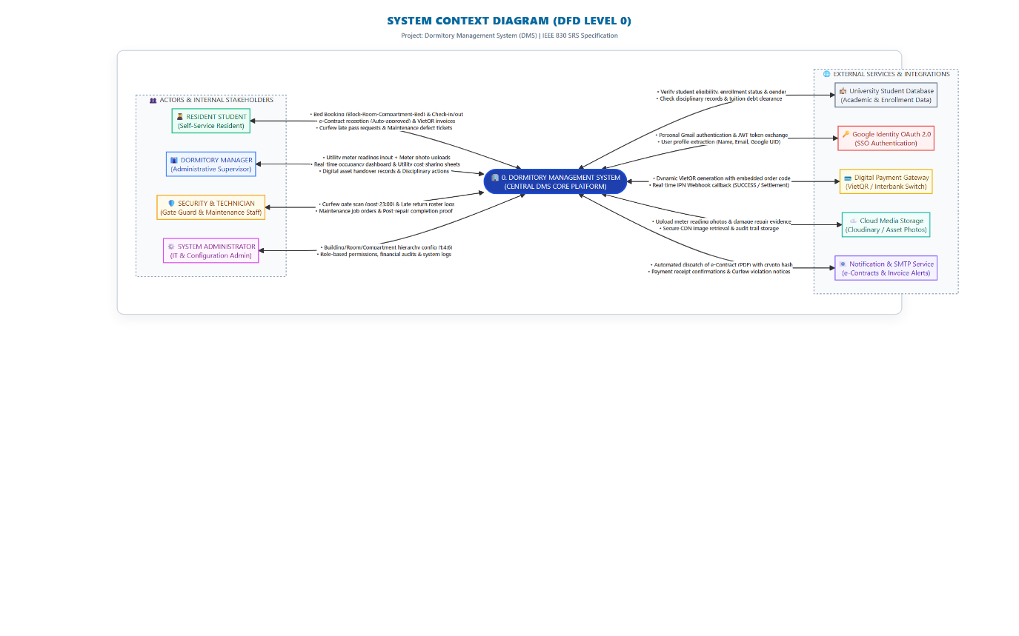

Figure 3.1: System Context Diagram (DFD Level 0) for Dormitory Management System

The System Context Diagram defines the operational boundary of the Dormitory Management System (DMS), illustrating bidirectional data exchanges between the central application and key stakeholders:

â€¢ Resident Student: Authenticates via personal Gmail SSO, submits bed reservation requests, confirms digital check-in/out checklists, views VietQR split utility invoices, and submits maintenance tickets. Receives booking confirmations, PDF e-contracts, and violation alerts.

â€¢ Dormitory Manager: Enters room-level utility meter readings with photographic proof, monitors real-time room occupancy dashboards, reviews auto-approved rosters, and manages disciplinary records.

â€¢ Technical & Security Guard: Inspects maintenance defect tickets, logs repair completions with photos, and verifies curfew gate entries past 23:00.

â€¢ System Administrator: Configures physical inventory (Block-Room-Compartment-Bed), defines room pricing, utility tariffs, VAT rates, and manages role-based access control (RBAC).

â€¢ External Services: Google OAuth 2.0 (Identity), VietQR / VNPay Gateway (Real-time IPN Webhooks), Cloudinary (Cloud Photo Storage for meter/damage evidence), and Resend/SMTP (Automated Email Delivery).

3.2 Swimlane Diagram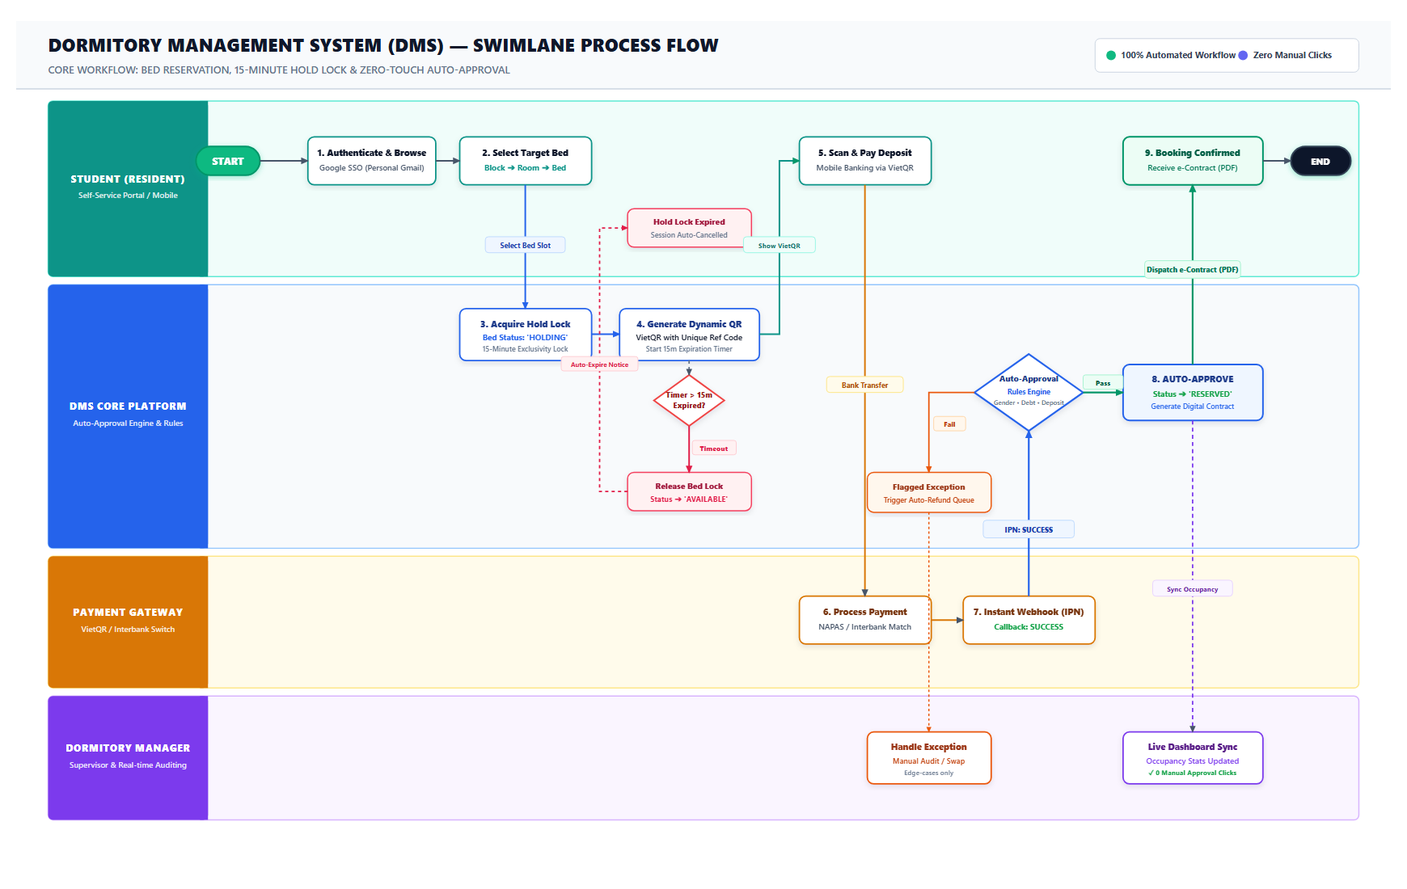

Figure 3.2: BPMN Swimlane Process Flow for Bed Reservation, Temporary Hold Lock & Zero-Touch Auto-Approval

The Swimlane Diagram models the end-to-end interactions across four functional lanes: Resident Student, DMS Core Platform & Auto-Approval Engine, Payment Gateway (VietQR/VNPay), and Dormitory Manager:

1. Student Lane: The student logs in via personal Gmail SSO, navigates the interactive floor visualizer (Block -> Room -> Compartment -> Bed), and selects a specific vacant bed. The student is presented with a 15-minute countdown modal and dynamic VietQR code, transfers the deposit via mobile banking app, and receives instant confirmation along with an official e-contract (PDF).

2. DMS Platform & Auto-Approval Engine Lane: Upon bed selection, DMS acquires a 15-minute exclusivity lock (Status: 'HOLDING') and starts an expiration timer. If the timer expires before payment, the lock is automatically released (Status: 'AVAILABLE'). When an IPN webhook is received from the payment gateway, the Auto-Approval engine validates three criteria (gender matching, active student eligibility with no debt, and 100% deposit receipt). When passed, the booking is instantly auto-approved (Status: 'RESERVED') and a digital contract with cryptographic hash is dispatched.

3. Payment Gateway Lane: Receives interbank funds from the student's banking app, validates order reference and amount, and transmits an asynchronous real-time IPN webhook (SUCCESS) to the DMS API.

4. Dormitory Manager Lane: Monitors the live occupancy dashboard as capacity updates in real time with zero manual approval clicks required during peak registration.

3.3 Entity-Relationship Diagram

The database architecture is designed in Third Normal Form (3NF) to support transactional integrity, automated bed allocations, digital check-in/out handover tracking, and room-level utility split billing.
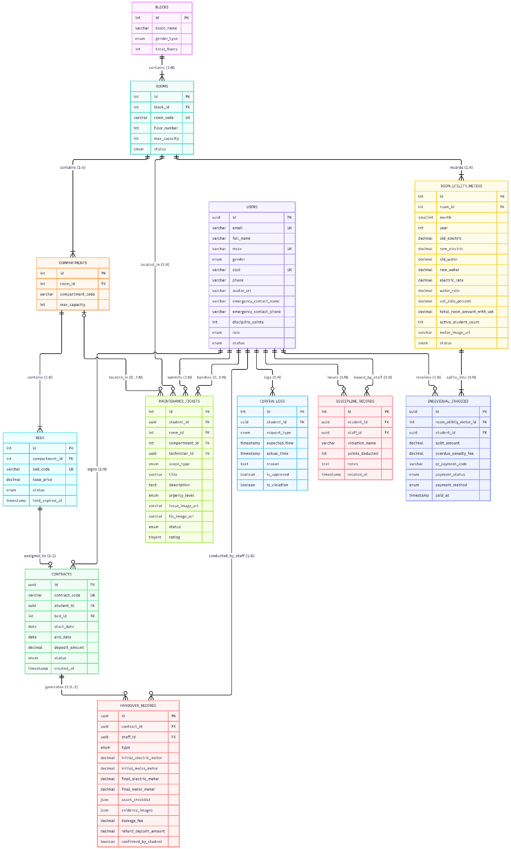

Summary Data Dictionary:
- BLOCKS: Stores dormitory building information, including building identifiers, block names, and total floor counts.
- ROOMS: Manages individual flat units within each block, tracking room numbers, maximum student capacities, and current occupancy status.
- COMPARTMENTS: Represents distinct cubicle living zones within a room (each room comprises exactly 4 compartments).
- BEDS: Identifies the atomic rentable inventory units linked to compartments, tracking individual bed slots and availability flags.
- USERS: Stores identity profiles for students, dormitory managers, and facility staff, maintaining personal and university emails, student codes, and emergency contact details.
- CONTRACTS: Manages student residency lease agreements bound to assigned beds, validity dates, contract life-cycles, and terms.
- HANDOVER_RECORDS: Contains paperless digital asset handover data for check-in and check-out procedures, recording baseline meter indices, photographic damage evidence, and student confirmations.
- ROOM_UTILITY_METERS: Records monthly master electricity and water meter readings at the room level, storing total consumption figures and cloud media URLs for photo audit verification.
- INDIVIDUAL_INVOICES: Holds per-resident split utility and room charges derived proportionally from the room meter, integrated with dynamic VietQR and VNPay payment statuses.
- CURFEW_LOGS: Tracks gate entry timestamps past the 23:00 curfew, linking records to prior electronic leave requests and validation statuses.
- DISCIPLINARY_RECORDS: Records disciplinary infractions, policy violation details, and cumulative penalty points assigned to students.
- MAINTENANCE_TICKETS: Manages resident facility repair requests, ticket statuses, assigned technician workflows, and post-resolution ratings.

3.4 State Diagram: Invoice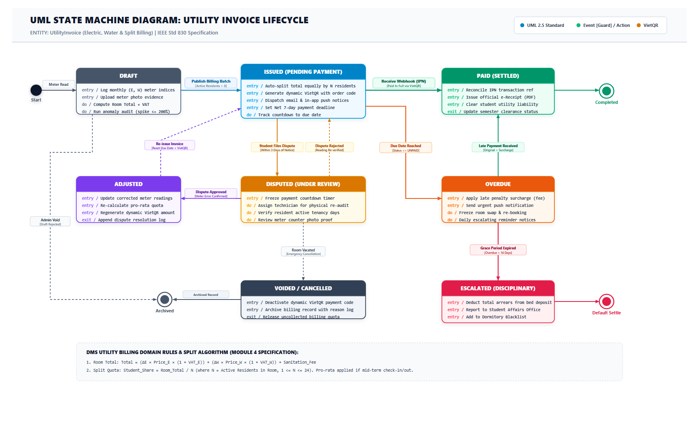

Figure 3.3: UML State Machine Diagram for Utility Invoice Lifecycle and Split Billing Engine

This UML State Machine Diagram governs the financial lifecycle of the room-level utility meter billing and individual split invoices:

â€¢ DRAFT: Generated monthly (25th-28th) when dorm staff records room electric and water meter indices along with photographic proof. The system executes anomaly validation (spike <= 200%) and computes the total room bill including statutory VAT.

â€¢ ISSUED (PENDING PAYMENT): The equal split algorithm divides the total room bill across all active resident students (N, where 1 <= N <= 24, with pro-rata adjustments for mid-term tenancy). Individual invoices are published with dynamic VietQR codes and a Net 7-day payment window.

â€¢ PAID (SETTLED): Payment gateway callback confirms transaction. System reconciles transaction reference, issues a digital e-receipt, and clears student liability.

â€¢ DISPUTED (UNDER REVIEW): Student files a meter contest ticket within 3 days. Payment timer freezes while staff audits meter photos or re-reads indices.

â€¢ ADJUSTED: If the dispute is verified, corrected meter readings are applied, pro-rata quotas are recalculated, dynamic VietQR amounts are regenerated, and the invoice is re-issued with a renewed due date.

â€¢ OVERDUE: Triggered when the payment deadline elapses without full receipt. System applies late penalty surcharges, sends daily escalating notices, and restricts room re-booking privileges.

â€¢ ESCALATED (DISCIPLINARY): Overdue beyond the 14-day grace period. Debt is reported to Student Affairs and deducted from the residency deposit at check-out.

â€¢ VOIDED / CANCELLED: Invoice is nullified due to room vacancy or administrative data correction.

3.5 State Diagram: Bed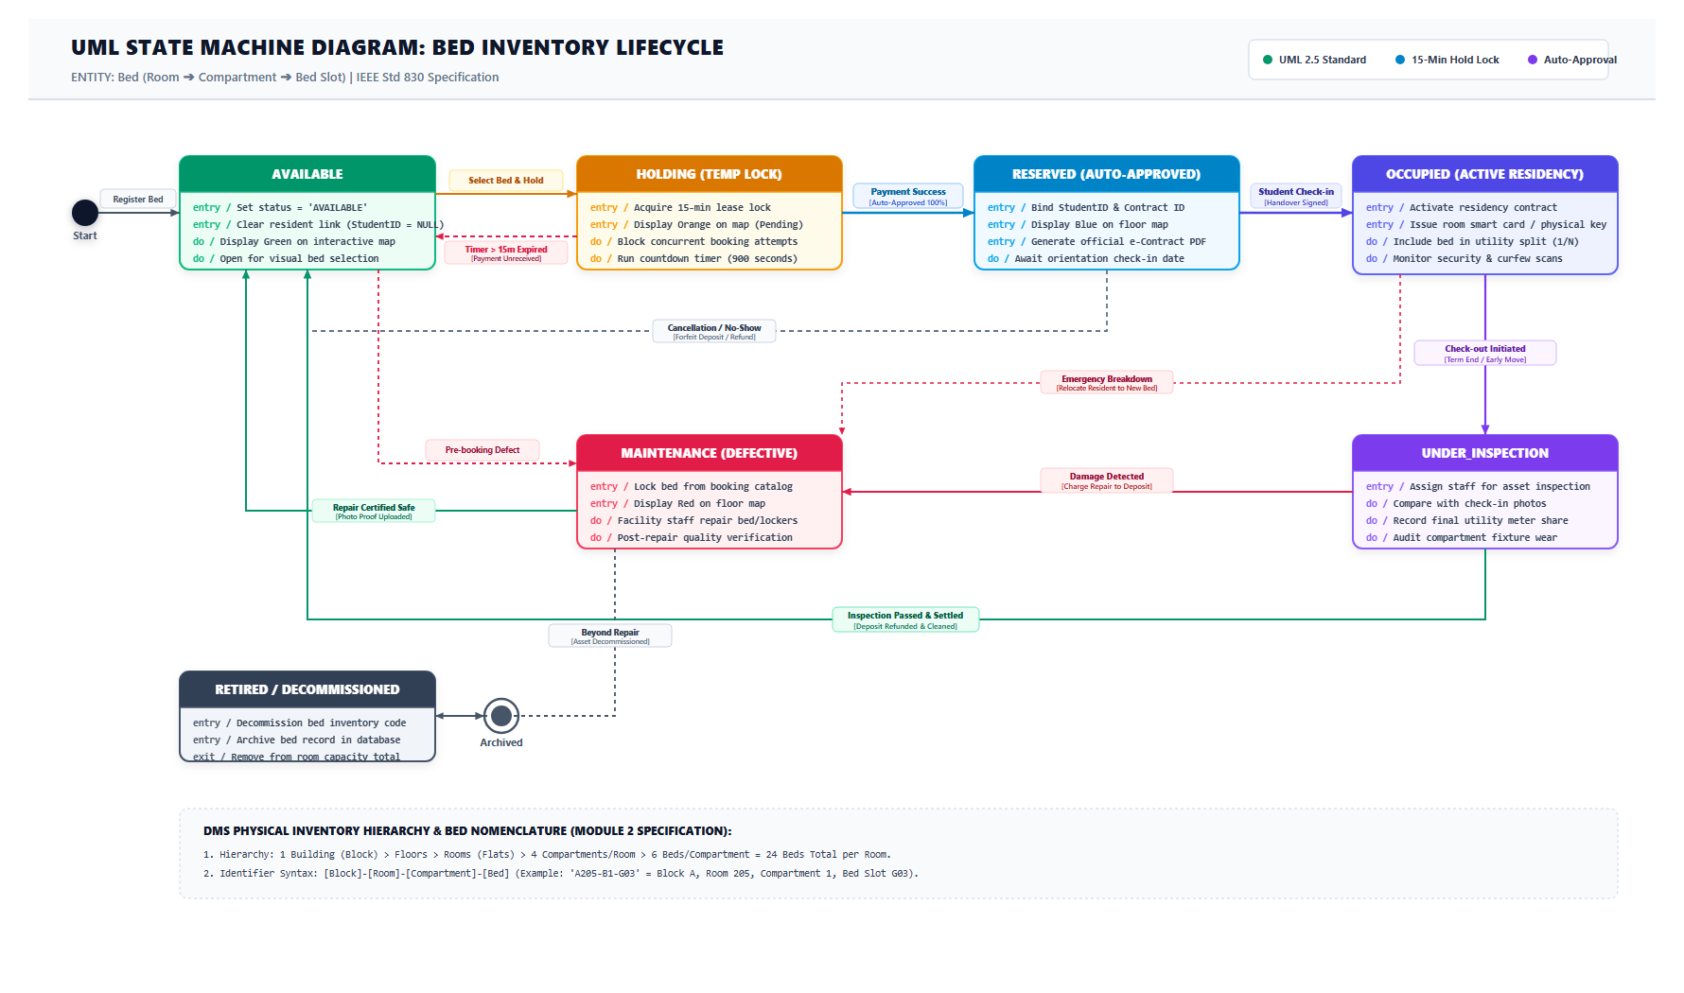

Figure 3.4: UML State Machine Diagram for Bed Inventory Lifecycle (1:4:6 Spatial Topology)

This UML State Machine Diagram tracks the operational lifecycle transitions of an atomic rentable bed slot:

â€¢ AVAILABLE: Initial clean, vacant state open for visual bed selection on the interactive floor map (displayed in Green).

â€¢ HOLDING (TEMP LOCK): Selected by a student, triggering an exclusive 15-minute lease lock (displayed in Orange). Concurrent selection attempts by other students are blocked. Reverts to AVAILABLE if the 15-minute timer expires before payment.

â€¢ RESERVED (AUTO-APPROVED): Reached when the payment gateway confirms deposit receipt and the Auto-Approval engine validates eligibility (displayed in Blue). An electronic contract (PDF) is issued, locking the bed until student arrival.

â€¢ OCCUPIED (ACTIVE RESIDENCY): Activated when the student completes on-site digital check-in handover (signing asset checklists and recording baseline utility meters). The bed is included in the monthly room utility cost split.

â€¢ UNDER_INSPECTION: Initiated upon check-out at term end or early move-out. Staff conducts an electronic handover audit against check-in photos and final utility meters. If passed with debts cleared, the deposit is refunded and the bed returns to AVAILABLE.

â€¢ MAINTENANCE (DEFECTIVE): Triggered if pre-tenancy defects, in-stay breakdowns, or check-out damages are detected (displayed in Red). Locked from booking until repairs are certified safe.

â€¢ RETIRED / DECOMMISSIONED: Permanently de-listed bed due to structural damage or room reconfiguration.

4. EXTERNAL INTERFACES & NFR
4.1 External Interfaces (Google OAuth 2.0, VietQR/VNPay, Cloudinary, Resend/SMTP)
â— User Interfaces (UI/UX): Web Portal architected as a responsive Single Page Application (SPA) utilizing React, Vite, TypeScript, and TailwindCSS (ShadCN UI design system). Features an intuitive hierarchical visual floor visualizer (Building -> Floor -> Room -> Compartment -> Bed), transparent personal invoice breakdown modals displaying master meter photos and dynamic VietQR codes, and touch-optimized mobile inspection checklists for staff conducting check-in/check-out rounds.
â— Software Interfaces:
- Google Identity Services (OAuth 2.0 API): Centralized Single Sign-On (SSO) governing domain-separated authentication for student personal Gmail accounts and staff institutional accounts (@fpt.edu.vn / @fe.edu.vn).
- Fintech Payment Gateways (VietQR / VNPay Sandbox API): Generates standard EMVCo dynamic QR payment codes with unique invoice codes and listens for asynchronous real-time IPN Webhooks to drive the zero-touch auto-approval pipeline.
- Cloud Media Storage (Cloudinary / AWS S3 API): Stores compressed photographic evidence (under 2 MB) for monthly master meter readings, check-in asset conditions, and post-repair maintenance tickets.
- Transactional Notification Services (Resend / SMTP API): Delivers automated PDF accommodation contracts with cryptographic hashes, monthly split invoice notices, payment receipts, and curfew violation alerts.
â— Hardware & Peripheral Interfaces: Accessible on standard modern desktop, laptop, tablet, and smartphone web browsers. Interfaces with mobile device cameras for meter and asset photo capture, and supports optional handheld barcode/QR scanners used by dormitory security personnel for curfew gate entry scans.

4.2 Non-Functional Requirements (Detailed)

Code | Criteria | Description | Metrics
NFR01 | Performance | Ensure fast and stable system response during peak hours when students select beds and view invoices. | - Vacant room/bed lookup API response time: average ≤ 300ms.  - Room-level utility cost split algorithm execution time for an entire building: ≤ 1 second.  - 95th percentile general API response time: < 500ms.
NFR02 | Scalability | Ensure the system prevents bottlenecks when an entire cohort attempts to select beds simultaneously upon registration opening. | - Support a minimum concurrency of 1,000 active students during the first 10 minutes of registration opening.  - Apply Pessimistic Locking or Redis Distributed Lock to prevent duplicate bed selection.  - Architecture allows horizontal scaling as the number of managed buildings/rooms grows without altering the database schema design.
NFR03 | Security | Protect student identity data and prevent unauthorized access to the administration portal. | - Temporarily lock accounts after 5 consecutive failed login attempts within 10 minutes.  - Encrypt Citizen ID numbers (CCCD) and parents' phone numbers at rest.  - Management portal login domain restricted strictly to @fpt.edu.vn and @fe.edu.vn; 100% block on other domains.  - Prevent OWASP Top 10 security vulnerabilities (SQL Injection, XSS, CSRF, IDOR).  - JWT Access Token lifetime ≤ 30 minutes; Refresh Token stored in HttpOnly Secure Cookies.
NFR04 | Reliability | Ensure financial data accuracy and high availability, even if a transaction fails mid-execution. | - System uptime ≥ 99.5%/month; ≥ 99.9% during registration opening windows.  - 100% of bill split and payment transactions execute within ACID Transactions with automatic rollback on error.  - Total utility split amount across room occupants must match the total room bill exactly (rounding discrepancy ≤ 1 VND).
NFR05 | Maintainability | Ensure ease of deployment, testing, and maintenance across independently developed domain modules. | - Domain-driven microservices architecture (Auth, Inventory, Billing, Ticket).  - 100% of APIs documented according to OpenAPI/Swagger standards.  - Statement Coverage ≥ 70% project-wide; Billing Split & Check-out Settlement modules: 100% Decision Coverage.
NFR06 | Usability | Ensure students, including first-year students unfamiliar with the system, can operate it immediately without additional guidance. | - Complete bed selection and hold lock process within a maximum of 3 main interaction steps.  - Vietnamese user interface, responsive from 360px (mobile) to 1920px (desktop).
NFR07 | Compatibility | Ensure stable operation across student-preferred devices, modern web browsers, and payment gateways. | - Support major modern browsers: Chrome, Edge, Safari (latest 2 versions).  - Authenticate both personal Gmail and institutional Google Workspace accounts via OAuth 2.0.  - Generate payment QR payloads compatible with VietQR and VNPay Sandbox.
NFR08 | Robustness & Safety | Prevent erroneous reservation cancellations due to intermittent network failures; provide early warnings for electrical overload or water leak risks. | - Payment gateway timeout at 10 seconds → retain bed reservation until the full 15-minute window expires without immediate cancellation.  - Electricity/water consumption spike > 200% compared to previous cycle → trigger immediate anomaly alert to Manager.
NFR09 | Compliance & Privacy | Protect students' personal data and adhere strictly to applicable statutory regulations. | - Comply with Decree 13/2023/NĐ-CP on Personal Data Protection.  - Apply statutory VAT rates to utility invoices correctly.  - Maintain 100% audit logging for Citizen ID accesses and payment histories, including timestamps and executing account details.

5. BUSINESS RULES & CONSTRAINTS

5.1 Core Business Rules

BR-01: Identity & Authentication Governance
- BR-01.1 (Student Login): Students must authenticate exclusively using their personal Google account (Gmail - @gmail.com) that was officially registered during university admission. Upon receiving the OAuth token from Google, the system queries the Student_Master_Data table:
  - Match Found: Grants authenticated session, auto-binding the session to the Student ID (MSSV), Full Name, and Academic Cohort.
  - No Match Found: Rejects authentication instantly with the error: "Email address not recognized in university records. Please contact Student Affairs."
- BR-01.2 (Staff & Management Login): Dormitory managers, technicians, security personnel, and administrators must authenticate strictly via institutional Google Workspace accounts ending in @fpt.edu.vn or @fe.edu.vn.
  - Any attempt to access managerial endpoints using standard personal emails (@gmail.com, @yahoo.com, etc.) shall be blocked at the API Gateway level.
- BR-01.3 (Identity Immutability): Students are prohibited from directly modifying their Student ID (MSSV), Full Name, or Registered Email on their profile portal. These fields remain read-only and may only be altered by a Super Administrator following formal university documentation.

BR-02: Facility Spatial Hierarchy & Capacity Quota
- BR-02.1 (Topological Hierarchy): Dormitory facility assets must strictly adhere to a four-tier hierarchical topology: Building -> Room -> Compartment -> Bed
- BR-02.2 (Capacity Ratio 1:4:6):
  - 1 Room comprises exactly 4 Compartments (designated as Compartment A, B, C, D or 1, 2, 3, 4).
  - 1 Compartment contains exactly 6 individual Beds (numbered G01 through G06), 6 individual lockable lockers, and dedicated compartment lighting and ventilation/air conditioning.
  - Standard Room Capacity: 4 Compartments x 6 Beds = 24 Beds (Students) per Room.
- BR-02.3 (Strict Gender Segregation): Each Building or designated Floor/Room is assigned a single gender constraint (MALE or FEMALE). The system strictly forbids assigning male and female students to the same Room or Compartment.

BR-03: Bed Reservation and Automated Approval
- BR-03.1 (Mandatory Specific Bed Selection): Students must select an exact bed position (Room -> Compartment -> Bed) on the visual interactive map. Generic room reservations without picking a specific bed are not permitted.
- BR-03.2 (First-Come, First-Served Policy): Eliminates all priority quota documentation (such as certificates for remote areas or social welfare). All students select beds equally in real-time.
- BR-03.3 (15-Minute Temporary Hold Lock): Selecting an available bed locks that bed temporarily for 15 minutes (shown in amber as "Holding") to prevent other students from selecting the same bed while payment is being processed.
- BR-03.4 (Automated Approval Engine): The booking is 100% automatically approved without manual manager review once all three conditions are met:
  - The student's gender matches the building/room gender requirement.
  - The student has active academic status, no outstanding debts from previous terms, and no active dormitory suspension.
  - The payment gateway confirms 100% receipt of the required deposit/room fee within the 15-minute window.
- BR-03.5 (Timeout Release): If payment is not completed within 15 minutes, the system automatically cancels the hold and returns the bed status to "Available".

BR-04: Digital Handover Protocol (Check-in and Check-out)
- BR-04.1 (Check-in Handover Verification):
  - A booking contract is activated only after the student and staff complete the digital Check-in Checklist.
  - The checklist covers shared room fixtures (door lock, water heater), private compartment items (mattress, locker key, socket, fan), and initial electric and water meter readings (with photos attached).
  - The student taps [Confirm Check-in] on their mobile device to complete key handover.
- BR-04.2 (Check-out Financial Settlement):
  - During checkout, staff inspect the room against the initial Check-in record to check for asset damages or missing items.
  - The final utility meter readings are recorded.
  - The net deposit refund is calculated automatically: Net Refund = Initial Deposit - Unpaid Utility Fees - Asset Damage Fees
  - After settlement, the bed is marked "Available" and the contract is closed.

BR-05: Room-Level Metering, VAT, and Split Billing
- BR-05.1 (Room-Level Measurement): Electric and water meters are installed and measured at the Room level (covering all 4 compartments together). Individual meters are not installed for each compartment.
- BR-05.2 (Photo Verification and Anomaly Alert): Staff entering monthly meter indices must upload a clear photo of the meters. The system rejects entries where the new index is lower than the previous index, and triggers a warning alert if consumption exceeds 200% of the previous 2-month average.
- BR-05.3 (Value-Added Tax - VAT Application): Utility costs include statutory VAT (e.g., 8% or 10%):
  - Electric Cost (with VAT) = (Electric Usage x Unit Price) x (1 + VAT Rate)
  - Water Cost (with VAT) = (Water Usage x Unit Price) x (1 + VAT Rate)
  - Total Room Bill = Electric Cost (with VAT) + Water Cost (with VAT) + Fixed Service Fees
- BR-05.4 (Equal Split Engine): The total room bill is divided equally among all active residents (N) currently living in the room: Individual Fee = Total Room Utility Bill (with VAT) / Active Students in Room (N)
- BR-05.5 (Independent Personal Invoices): The system creates individual invoices for each student with dynamic VietQR payment codes. Each student pays their own share directly; non-payment by one student does not penalize their roommates.

BR-06: Curfew, Late-Pass, and Disciplinary Policy
- BR-06.1 (Curfew Time): The daily dormitory curfew is 23:00. Gates close at 23:00 every night.
- BR-06.2 (Late-Pass Advance Request): Students returning late or staying out overnight must submit an electronic leave request on the portal before 21:00 on the same day.
- BR-06.3 (Infraction Tracking): Entering the gate after 23:00 without an approved leave request is recorded as 1 curfew violation strike.
  - 3 strikes per semester triggers automated email notices to parents and Student Affairs.
  - Accumulating more than 30 disciplinary penalty points forfeits dorm eligibility for the next semester.

5.2 System Constraints

Technical and Architectural Constraints (SC-01)
- SC-01.1 (Responsive Web Delivery): The system must be developed as a responsive Single Page Application (SPA), rendering cleanly across screen widths from 375px (mobile phones) to 1920px (desktop monitors) without layout breaking.
- SC-01.2 (Browser Compatibility): The web application must support all major modern browsers: Google Chrome (v110+), Mozilla Firefox (v110+), Apple Safari (v16+), and Microsoft Edge (v110+). Legacy Internet Explorer is explicitly not supported.
- SC-01.3 (Relational ACID Integrity): The database must use an ACID-compliant Relational Database Management System (such as PostgreSQL, MySQL, or MS SQL Server) to guarantee financial calculation precision and prevent data inconsistency during split billing.
Concurrency and Transactional Constraints (SC-02)
- SC-02.1 (Anti-Double Booking Concurrency Control): During peak registration periods (handling up to 1,000 concurrent students), the system must use database row-level locking (Pessimistic Locking) or Redis distributed locks on the Beds table to prevent two students from holding or booking the same bed at the same time.
- SC-02.2 (Hold Lock Expiration Task): An automated background worker (cron job) must run continuously to cancel unpaid reservations and release hold locks immediately when the 15-minute timer expires.
Security and Compliance Constraints (SC-03)
- SC-03.1 (Domain Whitelisting Validation): Backend APIs must strictly validate email domains:
  - Staff and Admin access requires email ending in @fpt.edu.vn or @fe.edu.vn.
  - Student access requires email ending in @gmail.com that exists in the pre-loaded university student database.
- SC-03.2 (Data Protection and Privacy): Sensitive student data, including Citizen ID numbers (CCCD), phone numbers, and emergency contact details, must be encrypted at rest and masked in public API responses.
- SC-03.3 (Web Security Compliance): The application must protect against standard OWASP Top 10 vulnerabilities, including SQL Injection, Cross-Site Scripting (XSS), Insecure Direct Object References (IDOR), and Cross-Site Request Forgery (CSRF).
- SC-03.4 (Token and Session Security): Authentication must use JSON Web Tokens (JWT). Access tokens must expire within 30 minutes, and Refresh tokens must be stored in secure, HttpOnly, SameSite cookies.
External Interface and Dependency Constraints (SC-04)
- SC-04.1 (Third-Party Identity Dependency): Login functionality relies on Google Identity Services (OAuth 2.0). Outages or maintenance on Google services will temporarily affect user login.
- SC-04.2 (Payment Gateway Latency): Generation of VietQR codes and payment confirmations depends on external fintech gateways (VNPay / SePay). Network latency between the payment gateway and the backend should remain under 3 seconds to clear hold locks promptly.
- SC-04.3 (Cloud Storage Limits): Meter photos and handover evidence images must be compressed to a maximum of 2 MB before uploading to cloud media storage (such as Cloudinary or AWS S3) to preserve bandwidth and storage limits.

5.3 Assumptions & Dependencies

5.3.1 Business and Operational Assumptions
- AS-01 (Pre-loaded Student Master Data): It is assumed that the University Registrar and Student Affairs Office have fully exported and imported the valid student admission database into the system prior to the opening of dormitory registration. This database must contain up-to-date Student IDs (MSSV), Full Names, Genders, and registered personal Gmail addresses.
- AS-02 (User Digital Capability and Device Access): It is assumed that all resident students and dormitory staff possess compatible personal computing devices (smartphones, tablets, or laptops) with active internet connectivity and camera functionality for scanning payment QR codes and capturing inspection evidence.
- AS-03 (Digital Payment Access): It is assumed that all registered students hold an active personal bank account or mobile wallet compatible with national banking transfer networks (NAPAS / VietQR / VNPay) capable of making real-time digital payments.
- AS-04 (Infrastructure Stability): The physical architecture and room layout (1 Room = 4 Compartments = 24 Beds) are assumed to remain static throughout an active semester. Any physical room renovation or partition modification will only be performed between academic terms.
- AS-05 (Utility Meter Integrity and Visibility): It is assumed that the master electric and water meters installed in each room are properly calibrated, operational, and physically accessible to staff for monthly manual inspection and clear photography.
- AS-06 (Regulatory Tariff Consistency): Utility unit prices (electricity tariffs, water tariffs) and the statutory Value-Added Tax (VAT) percentage are established by university authorities and configured by the System Administrator before generating the monthly utility billing cycle.
5.3.2 Technical and External Dependencies
- DE-01 (Google Identity Services Dependency): User login and Single Sign-On (SSO) are directly dependent on the availability and operational uptime of Google Identity Services (OAuth 2.0 API). Any outage on Google’s global authentication infrastructure will prevent users from logging into the portal.
- DE-02 (Fintech Payment Gateway and Webhook Delivery): The Automated Approval Engine (Auto-Approval) relies on external payment gateways (VietQR / VNPay / SePay) to transmit real-time Instant Payment Notification (IPN) webhooks. Network latency between the payment gateway and the backend must remain under 3 seconds to guarantee that 15-minute temporary hold locks are cleared on time.
- DE-03 (Cloud Media Storage Service): Storage of meter inspection photos, room check-in handover records, and profile photos is dependent on third-party cloud media providers (such as Cloudinary or AWS S3). The system assumes high availability (99.9% uptime) and sufficient storage bandwidth for fast image delivery.
- DE-04 (Transactional Email Delivery Service): Automated dispatch of booking confirmation notices, PDF electronic contracts, invoice payment reminders, and curfew violation notices depends on external SMTP or transactional email APIs (such as Resend, SendGrid, or Nodemailer). Delivery rates are subject to recipient mailbox quotas and spam filtering rules.
- DE-05 (Client-Side Browser Standards): The interactive visual bed selection map relies on modern HTML5, CSS3, and JavaScript rendering engines supported by modern desktop and mobile browsers (Chrome, Edge, Safari, Firefox). The system assumes client browsers have JavaScript and cookie storage enabled.

